SAP Learning Solution and SCORM
by Tammie Eldridge, Solution Principal, SAP America and Danielle Morrison, Senior Consultant, Innovapost

Since the inception of SAP Authoring Environment, SAP believes Sharable Content Object Reference Model (SCORM) is the emerging industry standard for inter-operability, while other standards will become obsolete. Thus, SAP developed learning objects in SAP Learning Solution (LSO) based on SCORM standards of the Advanced Distributed Learning (ADL), an initiative of the Department of Defense in the United States in cooperation with leading international organizations. SAP Authoring Environment is certified on SCORM 1.2. (To see a list of SCORM-certified Learning Management System (LMS) vendors, visit www.adlnet.gov.) In the near future, SAP plans to support SCORM 2004.

Based on the results of the SAP Corporate Research Center’s Life-Long Learning (L3) research project, SAP developed beyond what was already available in the SCORM standard. You can find more details about the L3 research project in our related article in HR Expert December 2006, “Part 3: Plan for and Implement SAP Learning Solution’s Authoring Environment.” This download outlines those differences.

While SCORM was moving in the direction of adaptive learning, it was not yet available in version 1.1 standards when SAP Authoring Environment was developed. The SCORM standard also did not provide in-depth guidelines around the re-use and versioning of content that SAP wanted to deliver. For example, the SAP Authoring Environment can re-use and version on the complete course (learning net), the learning object, the instructional element, and the metadata, which is more than what the SCORM standards consider. Figure 1 outlines how SAP features compare to the SCORM standards as well as the features built in SAP in addition to the SCORM standard.

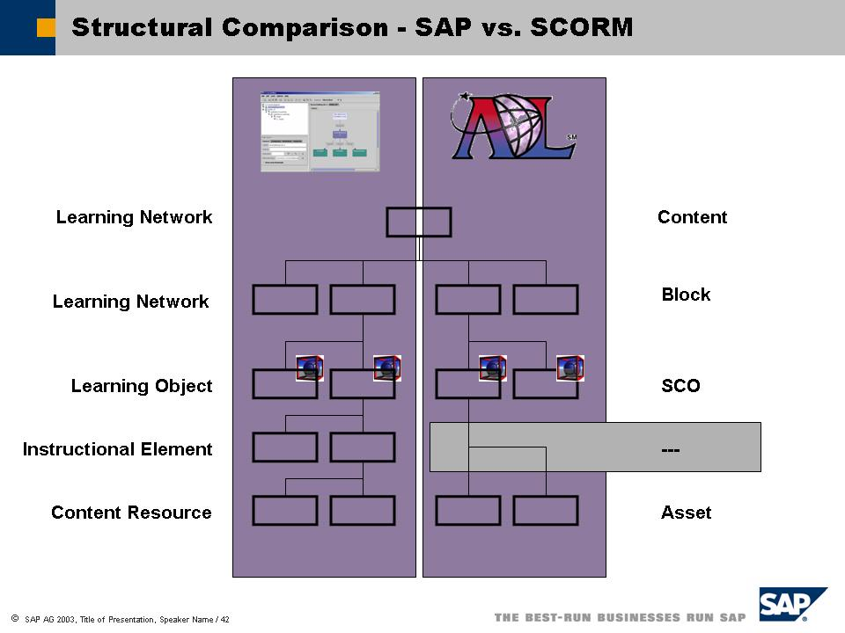

Figure 1 Compare SAP’s features on the left to SCORM standards on the right. SCO stands for Sharable Content Object, which LSO calls a learning object.

SCORM 1.1 and 1.2 only requires an LMS to track the pass/fail status on tests. SAP wanted to be able to do so on a more detailed level. SAP systems can track on a test-item level when utilizing Test Editor within LSO. Due to the reasons listed above, SAP needed to build additional technology around the SCORM standards, which is the reason for the conversion process.

Other LMS vendors can complete upload and download of courses without a conversion process. However, most are not capable of re-using and versioning this content like SAP can. Importing means that you brought your content in from an area on your hard drive into your local repository structure. It is also on your hard drive but within a central folder structure that only Authoring Environment recognizes.

Some SCORM conformant content providers offer content in a huge Shareable Content Object (SCO). While this does comply with the standard, truly effective SCORM content should be in smaller, reusable pieces. SAP LMS can track and bookmark the latter type of content.

Should I Conform to SCORM?

While the SCORM standard is mandated for any federal US government agency, other organizations should consider conforming to SCORM if:
- You want to design learning content that tracks learner performance and progresses and adapts accordingly
- You plan to use LMS or CMS to deliver and manage learning content
- You design content that you might reuse in other learning contexts
- You want to create a library of learning objects

You might opt not to conform to SCORM if:
- You create short-lived content
- Your effort to convert existing content would be too expensive
- You want only simple, static, hyperlinked content as reference material

Note
LSO conforms to SCO-RTE1+Mandatory and LMS-RTE2 (sharable content object, run-time environment) standards. This means that SAP LMS supports SCORM mandatory elements and some optional elements. See Table 1 for a summary of these standards.

Element | Mandatory | Supported | Remark
cmi.version | yes | yes
cmi.core.student_name | yes | yes
cmi.core.student.id | yes | yes
cmi.core.lesson_location | yes | yes
cmi.core.credit | yes | yes | Only field value “credit” supported
cmi.core.lesson_status | yes | yes
cmi.core.entry | yes | yes
cmi.core.score.raw | yes | yes
cmi.core.score.min | no | yes
cmi.core.score.max | no | yes
cmi.core.total_time | yes | yes
cmi.core.lesson_mode | yes | yes | Only field value “normal” supported
cmi.core.exit | yes | yes
cmi.core.session_time | yes | yes
cmi.suspend_data | yes | yes
cmi.launch_data | yes | yes
cmi.comments | no | yes
cmi.comments_from_lms | no | no
cmi.objectives | no | no | All subelements are not supported.
cmi.student_data | no | no | All subelements are not supported.
cmi.student_preference | no | no | All subelements are not supported.
cmi.interactions | no | no | All subelements are not supported.
Table 1 Elements that apply to RTE1+Mandatory and LMS-RTE2 standards

--
Tammie Eldridge is a solution principal for SAP America responsible for HCM solutions in the retail, telecommunications, utilities, and finance industries. Prior to this, Tammie was the solution manager responsible for SAP Learning Solution, Performance Management, and SAP Tutor. She also served as a consultant implementing mySAP ERP HCM solutions as well as building ROI business cases to help organizations justify implementing HCM solutions. Before joining SAP, Tammie served as a training manager for a major manufacturing company as well as implemented the mySAP logistics module. She received a bachelor’s degree in business administration in management and a master’s degree in Human Resources/Labor Relations from the University of Illinois. You may reach Tammie at tammie.eldridge@sap.com.

Danielle Morrison is senior consultant with Innovapost in Ottawa, Canada, with five and a half years of SAP HCM experience while employed with SAP Canada. Specializing in SAP Learning Solution for the past three years and a half years, she has been engaged on several international SAP Learning Solution projects in Canada, the US, Germany and Australia. Danielle was a Ramp-Up multiplier for SAP Learning Solution, has instructed SAP Learning Solution classes for customers and consultants, presented workshops, and helped draft several functional specifications for product enhancement as well as testing them for SAP development group in Germany. You can reach Danielle in Ottawa, where she lives with her husband and two teenagers, at danielle.morrison@innovapost.com.

