July 2005
For: “Two Ways to Easily Access Payroll Information,” by Rehan Zaidi, senior SAP consultant, Siemens Pakistan. The author provides a detailed introduction of clusters, describes their structure, and explains the purpose that they serve in SAP HR.
Usage of Clusters Within HR
by Rehan Zaidi, Senior SAP Consultant, Siemens Pakistan
Learn how the HR module uses clusters and use the code provided here to import data from a cluster.

The HR module utilizes clusters for storing information in a variety of areas. Some of the tables available for storing data clusters are PCL1, PCL2, PCL3, PCL4, and PCL5, as shown in Table 1. Clusters provide numerous advantages. For instance, they are best for storing long texts and notes related to infotypes. The monthly payroll results and payroll directory of an employee are also stored in cluster form in table PCL2.

PCL1 | TX | Infotype texts
PCL1 | TE | Travel expenses
PCL1 | TA | General data for accounting of travel expenses
PCL2 | ID | Interface toolbox – directory of interface results
PCL2 | ZL | Time wage types and work schedule
PCL2 | RU | Payroll results (US)
PCL3 | TY | Applicant data texts
PCL3 | AP | Applicant actions
PCL4 | P2 | Log for RPCALX0 and RPTIME00
PCL4 | U1 | Tax reporter forms for US
PCL5 | PY | Payroll data for personnel cost planning
PCL5 | CP | Planning run data for personnel cost planning
STXL | TX | Notes related to infotypes
Table 1 HR tables that use clusters

All these tables have a predefined structure. The structure of one of these tables is shown in Figure 1.

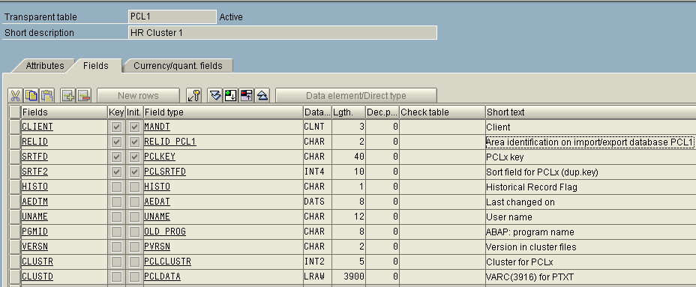
Figure 1 Structure of table PCL1

The tables that store clusters have the following fields in common:

RELID – This is a two-character field that identifies the cluster, e.g., TX, RX, etc.

SRTFD – This field denotes the key passed by the application program while importing and exporting data stored in a particular cluster. This is similar to key fields for a database table that uniquely identify a record. Generally, the key is comprised of the fields mentioned between RELID and SRTF2 in the table definition. In the case of table PCLX , there is only one – field SRTFD. However, in the case of table STXL, fields TDOBJECT, TDNAME, TDID, and TDSPRAS collectively make up the key.

SRTF2 – This serves an additional or a duplicate key field. This field is utilized when the fields SRTFD and RELID alone are not sufficient for uniquely identifying a table record. If a record is more than one line long, then a new row is inserted with a different SRTF2. For the first (or the only) row, this field has a value of 0. If the cluster data corresponding to the same SRTFD value extends over multiple lines, new rows are inserted with an incremented value of SRTF2 such as 1, 2, 3 and so on. The system judges the size of data and the possible increment in the SRTF2 field value, so the developer need not worry about it.

CLUSTR – This field shows the size (in bytes) of the data stored in a particular table row

CLUSTD – This contains the actual data, for instance the infotype text, stored in compressed form

Storing data in the form of clusters lets you create logical partitions within one database table. A single table may be used for storing data from different functional areas. This relieves the developer from creating separate tables (and programming update functions) for data belonging to each application area. For example, PCL1 table comprises of clusters TX and TE for storing infotype text and data of travel expenses, respectively. A two-character ID in field RELID identifies each cluster. Via clusters, a single table may be used to store data (such as long text related to a variety of application areas) under a separate cluster ID with a single key value. Otherwise, this information (e.g., long text, internal tables, and flat data structures) would have to be stored in separate table. Data may be exported to and imported from the table via the usage of EXPORT and IMPORT statements, respectively. For more information about these two ABAP commands, refer to the SAP documentation (SAP Library>mySAP Technology Components>SAP Web Application Server>ABAP Programming and Runtime (BC-ABA)>The ABAP Programming Language>Saving Data Externally>Saving Data Objects as Clusters>Data Clusters in the Database).

You may use the following code in your ABAP programs to import data from a cluster.
IMPORT ITAB1
ITAB2
STRUC1.............
FROM DATABASE TABNAME(CLUSTER_ID) ID KEY.
The data objects (residing in the cluster) that you want to access must be specified after the IMPORT keyword. While importing, it is unnecessary to access all the data objects stored in the cluster. The table name (TABNAME), cluster key (KEY), and cluster ID must also be mentioned in order to access the desired data. Moreover, you need to create the correct key (KEY) before calling the IMPORT statement.

When the IMPORT statement is executed, the data (in compressed form) that corresponds to the cluster key is read from the field CLUSTD. This data is decompressed (and converted) to its original form and then made available to the calling program.

On the execution of an EXPORT statement, data is compressed and then stored in the database.
Use your ABAP program and the following custom code to export data to the database:
EXPORT ITAB1 ITAB2 STRUC1
TO
DATABASE TABNAME(CLUSTER_ID) ID KEY.

