For http://www.ficoexpertonline.com/:

January Issue

For: “How to Create an Automatically Posted Intercompany Sales Journal Entry,” by Christian Eckhardt, IT analyst. The author provides answers to eight questions about such issues as the role of OBCA and SBPT and outbound and inbound parameters. Christian supplements his answers with relevant screenprints.

The following questions and answers refer to details such as customer numbers and vendor numbers referenced in the article, “How to Create an Automatically Posted Intercompnay Sales Journal Entry,“ published in the January 2004 issue of the FI/CO Expert newsletter.

Questions and Answers on Automated Accounting for the Purchasing Company in Intercompany Sales

by Christian Eckhardt, IT Anaylst

Question 1. Outbound vs. Inbound
In the WE20 and WE42 transactions, I see the words inbound and outbound a lot. This is confusing. Which is which? Is the sales billing transaction looking for outbound parameters for the Bill-To partner 14855? If yes, how does R/3 know from the sales billing what the Bill-To partner number is? Also, after the IDoc is created based on the data in Output Type RD04's processing routine, and based on the output parameters for partner 14855, how does R/3 know to look for inbound parameters for vendor 103328? I can see the mapping of 14855 to 103328 in transaction code OBCA. However, this does not explain why R/3 would bother to look at the settings for 103328 in transaction code WE20.

Answer 1. Outbound means the process getting the outgoing intercompany invoice formated to an IDoc. Inbound means taking this IDoc and posting this to the receiving company code. SAP is getting the 14855 number from the assigned partner function for Output type RD04. (See Figure 1 of transaction code V/40.)

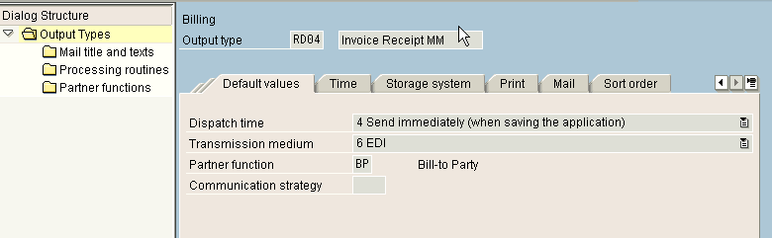
Figure 1 Transaction code V/40

Now, the tricky thing is the assignment from 14855 to 103328. SAP gets this data from the following IDoc field: E1EDKA1 Qualifier RE (which is equal to BP) field PARTN (Figure 2). SAP is taking the string 0000014855 and looking up the assigned vendor in the table maintained with transaction code OBCA (Figure 3).

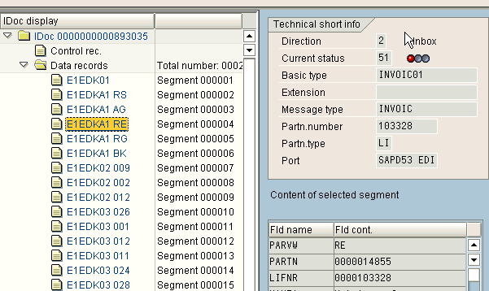
Figure 2 IDoc field: E1EDKA1 RE, field PARTN

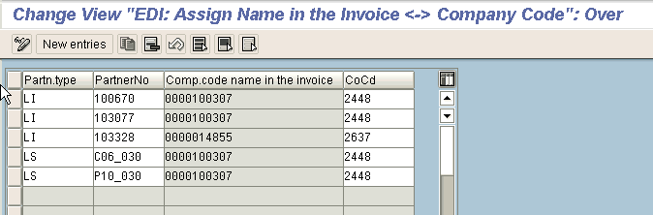
Figure 3 Transaction code OBCA

Question 2. The role of OBCA
Perhaps I did not understand your explanation of the purpose of transaction code OBCA. In the IDoc field E1EDKA1 RE PARTN (Figure 2), the vendor (LIFNR) number is already there. Is transaction code OBCA the reason it is there?

Answer 2. No. Instead, notice in the screen with transaction code OBCA (Figure 3) that the partner field is 103328, and that this goes into a different field of the IDoc (see Figure 4) than the LIFNR value that you see back in Figure 2 (where you see a string 0000103328). It is only by coincidence that we have that (indirect) link here, because we have an intercompany process and we are sending an IDoc and receiving it that exact same SAP R/3 system. Think of EDI between different partners as you can see in the screen shot of transaction code OBCA: We have also partners mentioned as P10_030, which are logical systems (LS); for example, other SAP systems of suppliers. So the keyfields of this table are: Partn.type, Partn.number, and Comp.code name in the invoice. The link from the IDoc to this table is the partner number of the IDoc field E1EDKA1 RE PARTN. The Partn.type and PartnerNo. are coming from the IDoc header. If you have different systems, this data has to be equal.

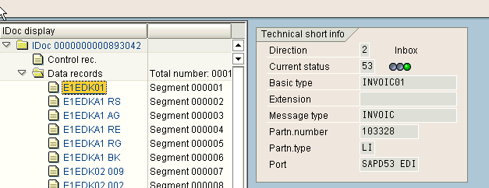
Figure 4 Transaction code OBCA

Question 3. The partner profile outbound parameter setting: "receiver port"
If I double-click on an entry for Outbound Parameters in transaction code WE20, I see a screen with several tabs. If I choose the tab called Outbound Options, I see a field called Receiver Port. This is confusing. Why would the outbound portion of an interface from one system to another system require a receiver port? I would expect to see a setting called sending port. Isn't that the purpose of an outbound message, to send?

Answer 3. The outbound message needs a receiving port because this specifies the application or system you are communicating with. To define a sending port would make no sense, because the sending port will always be SAP. With defining a receiving port you have the possibility to get an IDoc to different systems. Therefore, you do not have to assign a receiving port for the inbound message, because this will be the interface of the application or system, i.e., SAP. The definiton of the ports is done in transaction code WE21. (See Figure 5.)

As you can see, you have different possibilities to connect, even to other systems. That is what makes it important to define a receiving port (just say application or system) for outbound messages. I am using a transactional RFC.

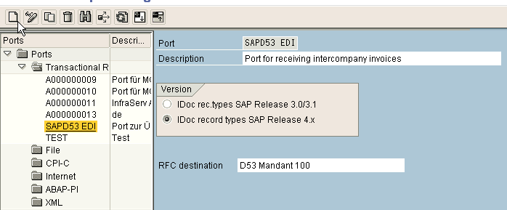
Figure 5 Transaction code WE21
Question 4. Message code vs. logical message vs. message type
The transaction code WE42 seems to be about inbound process codes. If I double on one such as INVL, there are a few screens that I can scroll through. On one screen, I see how it is linked to one particular function module (IDOC_INPUT_INVOIC_MRM). On a further screen, I see something called Assignment to Logical Message. There, I can link the process code to a message type (such as INVOIC) and to a message code (such as MM or FI). Of course, I can see these field names in the WE20 transaction code also. In WE20, I can see how I can make an entry into the Inbound Parameters section for message type INVOIC (for example). But, if I make an entry without that, and then choose from the detail screens the tab called Inbound Options, I see a field there called Process Code where I can type in MR01, for example. So, it is confusing why I need to create the logical message settings in transaction code WE42. It is also confusing to understand what the purpose of the message code is.

Answer 4. The message code allows you to make SAP do different things by getting different parameters. The outbound message gets the parameters from the customizing settings for Partner type KU and is searching an equivalent entry in the inbound parameters for Partner type LI. For example, we use two ways to get our invoices posted: by logistics invoice verification for replenishment POs and “manually“ posting via transaction code FB01 for drop-shipments. For both cases you have the same customer and vendor. But, with a different output type for the drop-shipment invoices (not RD04 – create a second one, ZRD4 perhaps), you could make different postings by assigning these message variant codes to different process codes. In Figure 6 there are the two entries. What’s not visible in this figure is that the first one is linked to output type ZD04 and the second one to RD04.

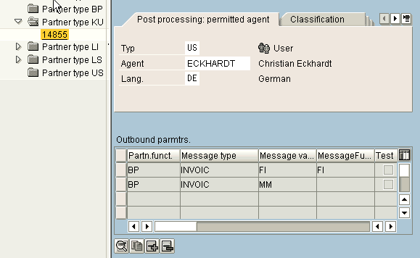
Figure 6 Postings with a different output type for the drop-shipment invoices
In Figure 7 are my three inbound parameters entries. If you look at the details for two of them (Figures 8 and 9), you can see that there are different process codes maintained for each entry.

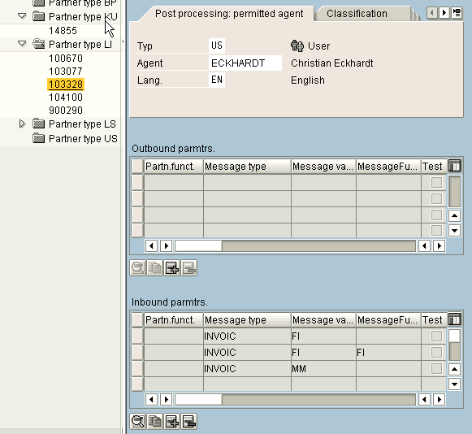
Figure 7 Entries for three inbound parameters

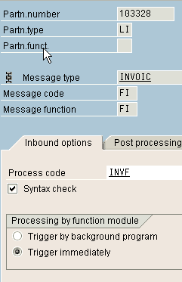
Figure 8 Entry for INVOIC FI FI

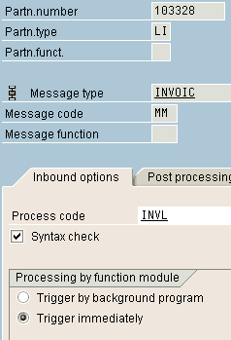
Figure 9 Entry for INVOIC MM

If you don’t want to differentiate your processing, you won’t have to do anything here. Remember, IDocs get shipping dates to many different working suppliers, warehouses, forwarding agents, etc., so that is why this part is so complex.

Question 5. Additional posting Instructions
There are a great many instructions that R/3 will need to post an invoice verification document – for example the document type code to use. Does the IDoc hold all of these instructions? And, if so, how does it get those?

Answer 5. I will show you the steps on screen in the following figures (Figures 10, 11, 12, 13, and 14). Note that if you forget the customizing of the following tables, you get clear instructions in the status overview for the IDocs (transaction code WE05).
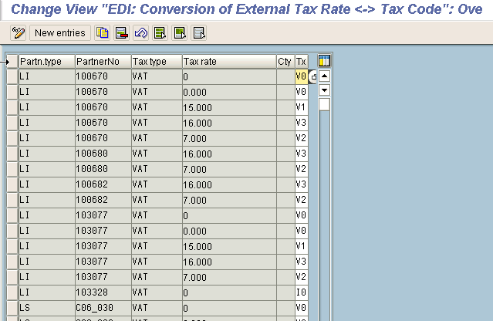
Figure 10 Transaction code OBCD to define the tax code for the incoming invoices

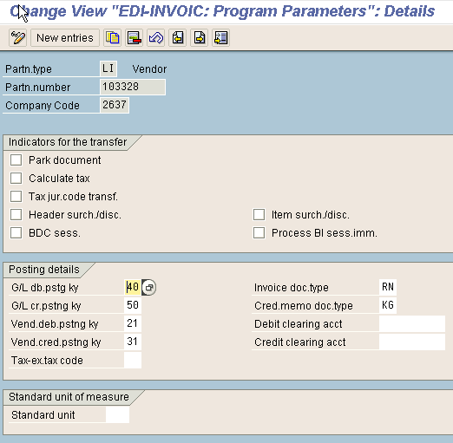
Figure 11 Transaction code OBCE for setting the program parameters for posting with FB01

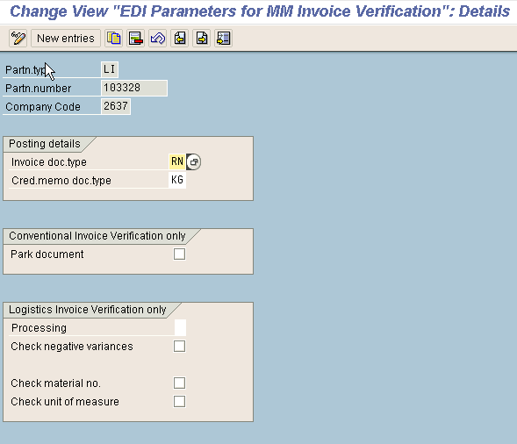
Figure 12 Transaction code OMRY to set program parameters for posting with MM Invoice Verification
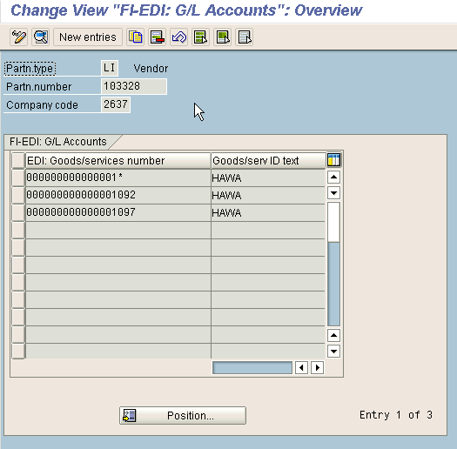
Figure 13 Assign the materials of the billing document to an G/L account in the receiving company code (2637 in my example). You maintain these assignments with transaction code OBCB.

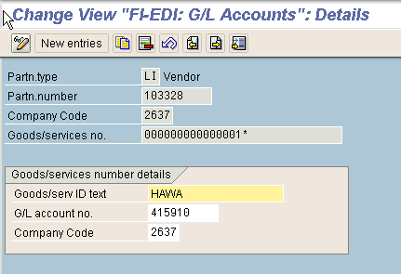
Figure 14 You can also do a generic entry so that you won’t have to maintain a lot of material. If you double-click an item, you get the assigned G/L.
The Goods/serv ID text has just an informational character.

Question 6. Where do I create the RFC instructions for the “receiving“ port?

Answer 6. The port definiton is done in transaction code WE21.

To define the remote function call (RFC) destination you have to use transaction code SM59 (Figure 15).

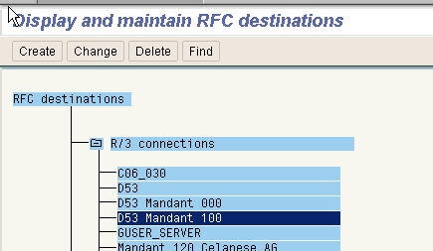
Figure 15 Transaction code SM59

Just fill in connection type 3, the IP address or name of the target host, language, and client, then save. This RFC connection has to be assigned to the port which is maintained in transaction code WE21.

For the purposes of this example you have to maintain a R/3 connection (Figure 16). Just fill in connection type 3, the IP address or name of the target host, language, and client, then save.
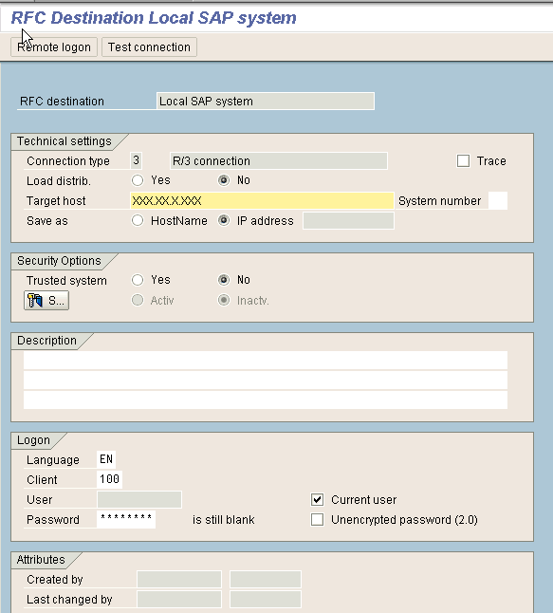
Figure 16 RFC connection maintenance

This RFC connection you have to assign to the port maintained in transaction code WE21 (Figure 17).

Figure 17 Transaction code WE21

Question 7. Why not mention transaction code SBPT?
In the SAP online help for the IMG, in the SD Billing>Intercompany Billing section, under the entry for Automatic Posting to Vendor Account (EDI), it lists transaction code WE20 to use for the outbound parameters, but transaction code SBPT for the inbound parameters. Is transaction code WE20 truly the best place to declare both the outbound and the inbound parameters?

The transaction code SBPT is an area menu where you have your access tree for the IDoc basis (Figure 18). So you get most of the transaction by expanding this tree, but the faster way is to have the direct access with transaction code WE20.

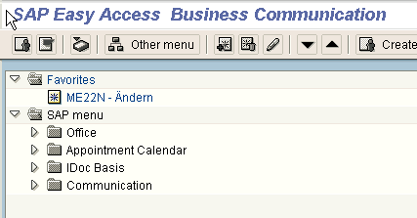
Figure 18 Transaction code SBPT

Question 8. What do I do when I have more than one supplying plant?

The vendor is assigned to one supplying plant in the vendor master data. Do I have to maintain more than one entry for inbound and outbound parameters in transaction code WE20 when I have different supplying plants and therefore different vendors?

Answer 8. No, you leave your existing entry in WE20 (i.e., for 14855 and 103328) and just maintain a head office (i.e., 103328) for the vendor assigned to another plant (Figure 19). Remember: If the ship-to-party (i.e., 14855) stays the same, the vendor account which gets his journal entry is determinated in transaction code OBCA (Figure 3). You just have to maintain new entries in WE20 if you want the invoices posted to the different vendor accounts.

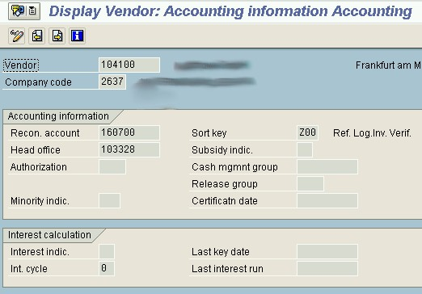

Figure 19 Maintain head office in vendor accounting information
Question 9. Any last words of wisdom?

Answer 9. I think the easiest way to explain this entire sequence is to take the case of one intercompany PO from the U.S. site (Bill-To customer 14855) to the German site (vendor 103328).

- Step 1: The U.S. site makes PO 450000123 to vendor 103328 for delivery to the U.S. plant.
- Step 2: In transaction code MK02, this vendor is mapped to plant 0011 which, because it is not linked to the same company code as the U.S. site’s plant, tells R/3 that it is dealing with an Intercompany purchase. It wants to respond by inserting a record in the supplying plant’s delivery due list. But, for which customer? The transaction code OMGN is setting customer 14855 for that U.S. plant.
- Step 3: The German plant creates the delivery document, and then records the shipment to customer 14855. (i.e., a goods issue posted to the delivery).
- Step 4: The nightly batch billing program launches.
- Step 5: The system automatically creates the sales billing from the German site to customer 14855.
- Step 6: The message determination finds output type RD04 as relevant for this particular sales billing.
- Step 7: Output type RD04 is linked in transaction code V/40 to the transmission method EDI.
- Step 8: Because the Sold-To customer number is 14855, and because the output method is EDI, and because you have an entry in transaction code WE20 for 14855 as Partner Type KU, and because in the entry you have made some outbound parameters for partner function BP (Bill-To) with message code MM (for dropshipment it is FI) and receiver port D53 (in this case the same system and the same client as sending system), the result is that R/3 automatically takes the data values from output type RD04 and uses those to create an IDoc.
- Step 9: If you do not do any further customization, that IDoc would just sit there. However, if you have the following items in place, R/3 will automatically take the values from the IDoc and use them to post an invoice verification entry against the original PO number 450000123: an entry in transaction code OBCA that maps the Partner 0000014855 to the Partner Type LI (vendor) as partner 103328 + CoCode 2637; an entry in transaction code WE20 for 103328 as Partner Type LI that has inbound parameters for message type INVOIC MM (or FI when billing a drop-shipment); an entry in transaction code WE42 that maps INVOIC MM to process code INVL; in WE42 the INVL process code is also linked to function module IDOC_INPUT_INVOIC_MRM; you have assigned the invoice and credit memo types and the tax type for partner 103328 with transaction code OBCE.

Tip! When you are using the module IDOC_INPUT_INVOIC_MRM for the logistics invoice verification via EDI and you have a batch split on one main item, you have to deactivate the billing of the sub items and change this to billing of the main items in the customizing of the copying control for billing documents (transaction code VTFL).

